**EC312 Homework 28**

Name: SOLUTIONS

1. Consider Figure 20.8 (a) from the Forouzan text. Assume link-state routing is used.

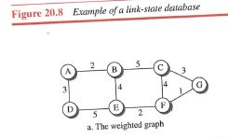

(a) Which routers does Router C send LSPs to? (b) Sketch the LSP sent by Router C.

(c) Show the correct routing table for node C (d) Show the correct routing table for node E

(a) B, F, G

(b) C

B 5

F 4

G 3

(c) Routing Table for Router C:

Destination Next element Weight

A B 7

B B 5

D B 10

E F or G 6

F F or G 4

G G 3

(d) Routing Table for Router E:

Destination Next element Weight

A B 6

B B 4

C F or G 6

D D 5

F F 2

G F 3

1. Determine the correct routing table for Node A in Figure 20.35 from the Forouzan text.

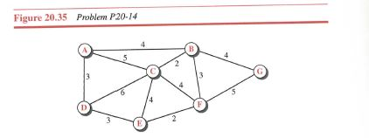

Routing Table for Router A:

Destination Next element Weight

B B 4

C C 5

D D 3

E D 6

F B 7

G B 8

3. Problem 2 on page 14 of the Lesson 28 notes.

Consider the network shown below which uses distance vector routing. **You are router *C***. You have just received the following distance vectors:

from B: (4, 0, 8, 13, 7, 2)

from D: (17, 11, 6, 0, 8, 10)

from E: (8, 6, 2, 10, 0, 4).

Your distances to B, D and E are 7, 4 and 6, respectively. What is your new routing table (include the distance and next hop for each destination)?



|  |  |  |  |  |  |  |  |  |  |  |  |
| --- | --- | --- | --- | --- | --- | --- | --- | --- | --- | --- | --- |
| From B  (7) | |  | From D  (4) | |  | From E  (6) | |  | Destination | Next Hop | Delay |
| A | 4 |  | A | 17 |  | A | 8 |  | A | B | 11 |
| B | 0 |  | B | 11 |  | B | 6 |  | B | B | 7 |
| C | 8 |  | C | 6 |  | C | 2 |  | D | D | 4 |
| D | 13 |  | D | 0 |  | D | 10 |  | E | E | 6 |
| E | 7 |  | E | 8 |  | E | 0 |  | F | B | 9 |
| F | 2 |  | F | 10 |  | F | 4 |  |  |  |  |